Task 11.4 Workforce Productivity Dashboard -
Employee attendance, skill utilisation, shift
performance

Objective:
The objective of this project is to analyze workforce productivity, employee engagement, and retention metrics to help HR and management make data-driven decisions regarding performance improvement, promotions, and compensation strategies. Data Cleaning and Transformation use of DAX queries and Data Modeling (Star Schema Approach one to one relationship).

Dataset Description:
Dataset consists of 2 tables employees and monthly_performance.
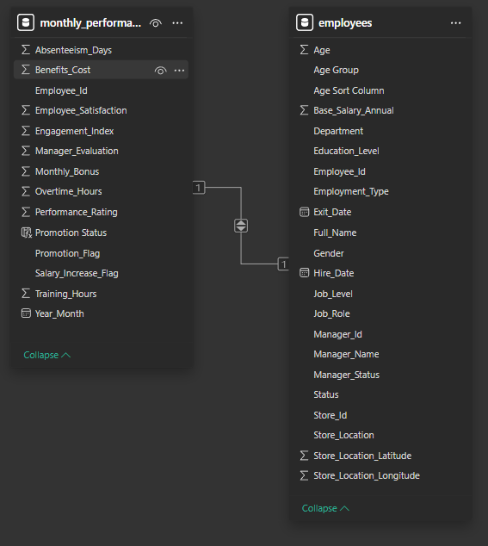
Columns used in Dashboard:
Employee_ID, Department, Job_Role,Job_Level, Gender, Education_Level, Performance_Rating, Employee_Satisfaction, Engagement_Score, Overtime_Hours,
Promotion_Status, Monthly_Bonus, Salary_Increase_Flag, Training_Hours.

Data Cleaning & Transformation (Power Query):
Performed the following steps:
- Removed null values
- Standardized column names
- Converted data types properly
- Created calculated column:
  - Salary_Increase_Flag (True/False)
- Ensured categorical fields are consistent

Key KPIs Created:
Page 1 - Workforce Productivity Dashboard
KPI Cards:
- Total Employees - 8k
- Average Performance Rating - 3.91
- Average Employee Satisfaction - 7.45
- Average Engagement Score - 7.43

Visual Chart Analysis:
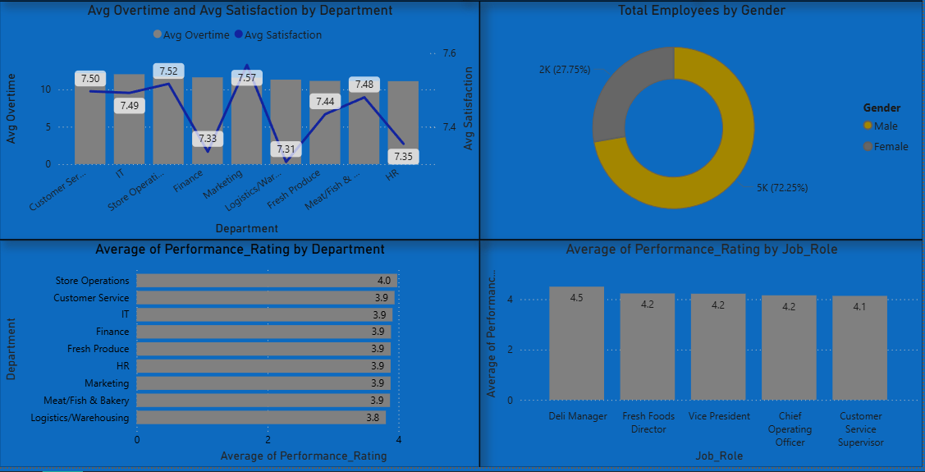
- Average Overtime Vs Satisfaction by Department - Line & Stacked Column Chart
- Average Performance Rating by Department - Clustered Bar Chart
- Average Performance Rating by Job Role Top 5 - Clustered Column Chart
- Total Employees Gender Distribution - Donut Chart

Page 2 - Workforce Retention & Growth Analysis
KPI Cards:
- Total Salary Increases - 108
- Total Promotions - 21
- Average Training Hours - 2.67
- Active Employees - 6K

Visual Chart Analysis:
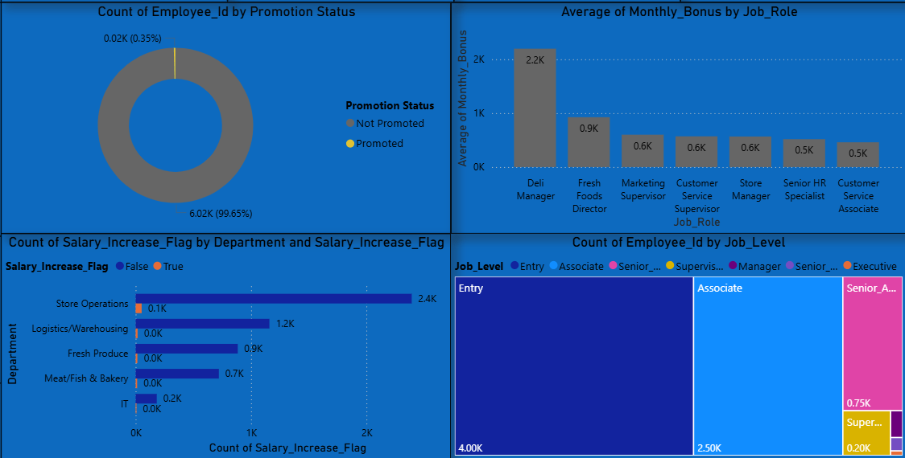
- Promotion Status Distribution - Donut Chart
- Monthly Bonus by Job Role Top 7 - Clustered Column Chart
- Salary Increase by Department Top 5 - Clustered Bar Chart
- Employee Count by Job Level - Tree Map

Business Insights Derived:
Insight 1:
Entry and Associate level employees form the majority of the workforce

Insight 2:
Promotions are very limited compared to total workforce, indicating strict promotion policy.

Insight 3:
Certain departments show higher overtime but lower satisfaction, suggesting potential burnout risk.

Insight 4:
Higher job roles receive significantly larger monthly bonuses.

Insight 5:
Most employees did not receive salary increments.

Slicers & Interactivity:
Implemented interactive filters:
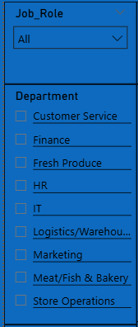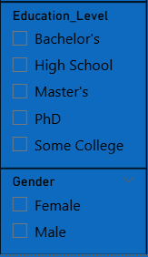
- Job Role
- Department
- Education Level
- Gender
Slicers are synced across both pages for consistent filtering experience.

Key Business Value:
This dashboard enables:
- Performance tracking across departments
- Promotion and salary trend analysis
- Workforce structure understanding
- Compensation comparison by role
- Data-driven HR decision-making
Conclusion:
This dashboard provides a comprehensive analysis of workforce productivity and retention metrics. It helps HR teams identify performance gaps, evaluate compensation fairness, and improve employee engagement strategies.

